Instruction Manual
PH-Meter
Model:PHS-3CU
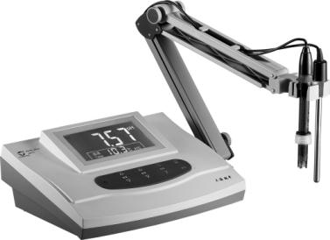
Content
- Overview ······················································1
- Technical Parameter ··········································2
- Installation ·····················································3
3.1Components Installation ·································4
- Operating ······················································5
4.1. Operation Panel ··········································5
4.2 Operation ··················································6
4.3 Temperature Setting ·····································7
4.4 Calibration ················································7
4.4.1 1 Point Calibration ······························8
4.4.2 2 Point Calibration ······························9
4.4.3 Slope Restoring ································10
4.5 Testing ····················································10
4.5.1 pH Testing ······································10
4.5.2 mV Testing ·····································11
- Maintenance of Equipment ································12
- Preparation of Buffers ······································12
- Maintenance of Electrode ··································13
- Reference of Pollutant and Cleaning Compound ·······14
- Accessories ··················································15 Appendx 1:Comparison of Buffers ·····················15
Appendx 2:Trouble Shooting ······························16

Appendix 2: Trouble Shooting
Display | Reasons | Solution
Show"Err"all the  time after turning  on | The memory chip  goes wrong | Turn off and wait.  Try several times.  If the problem is still  exist. Please contact  With your distributor
mV area shows  "over" but  temperature area  is normal | Input potential is  over the testing  range | Connect the Q9 plug  (11) to the pH  electrode interface.  If the problem  is still exist,please  contact with your  distributor
Press"OK" for 3s,  show "5Y5 r5t",  in testing mode. | System reset function,  remind you wether  need to reset the  system | Press"OK" , If you  need. Otherwise  press other keys  to exit.
Press"Set EO" or  "Slope",show  flicker"5Y5 Ye5" | Protection for pressing  key in error. Remind  you wether need to  calibrate | Press"OK" , If you  need. Otherwise  press other keys  to exit.
Wrong Data | Display Problem | Please contact with  your distributor

1.Overview

PHS-3CU model pH meter is widely used in laboratory.It’s developed from PHS-3C. Using new appearance, bigcharacter LCD. PHS-3CU can recognize 4.00pH,6.86pH,9.18pH,3 normal buffers automatically.It also has protection and reminder function for easy operating.

PHS-3CU is very popular in university,academe,laboratory to text the pH, mV of the sample solution. Most of all, you can test the potential of the ion-selective electrode.

NOTE:
- Please read the manual before operating.
- Examination is strictly required after 1 year. Please send
the equipment to the metrological service or other
relevant departments to do the examination before using.
- The warranty of pH Electrode is 1 year. Please replace it
after 1 year.
- Dipping the pH electrode in 3 mol/L KCL solution for 24
hours in first time or nonuse for long time.
- Please take the pH electrode manual as the standard.

- Technical Parameter
Class | 0.01 Class
Range: | pH: (-2.00~19.99)pH
 | mV: (0~±1999)mV(auto display)
Accuracy: | 0.01pH
 | 1mV
Automatic recognition of 4.00pH,6.86pH,9.18pH,3 buffers function
Temperature Compensation: | Hand/Auto(0~80)℃
Error of electronic unit: | pH:±0.01pH
 | mV:±1mV±1d
Error of equipment: | ±0.02pH±1d
Electronic unit input current: | ≥1x10¹²A
Electronic unit input impedance: | ≥1x10¹²Ω
Error of temperature  compensation: | ±0.01pH
Error of electronic unit  repeatability: | pH: 0.01pH
 | mV: 1mV
Error of equipment repeatability: | ≤0.01pH
Stability of electronic unit: | ±0.01pH±1d/3h
Packing size: | 290mmx210mmx95mm
N.W.: | 1.5kg
Using Condition: | a)Temperature: (5~40)℃
 | b)Humidity: ≤85%
 | c)Power:DC(9v,1.0A)V,(50~60)Hz
 | d)No magnetic interference

9. Accessories

PHS3CU main equipment 1
E201C model pH electrode assembly 1
Temperature electrode 1
Supplied accessories 1

If you need to test the ORP of redox or the mV of ion-selective electrode,please purchase electrode converter(Optional).

Appendix 1: Comparison table of Buffers
Temp.  ℃ | 0.05mol/kg  Potassium  hydrogen  phthalate | 0.025mol/kg  Monopotassium  phosphate+  Monosodium  orthophosphate | 0.01mol/kg  Borax
5 | 4.00 | 6.95 | 9.39
10 | 4.00 | 6.92 | 9.33
15 | 4.00 | 6.90 | 9.28
20 | 4.00 | 6.88 | 9.23
25 | 4.00 | 6.86 | 9.18
30 | 4.01 | 6.85 | 9.14
35 | 4.02 | 6.84 | 9.11
40 | 4.03 | 6.84 | 9.07
45 | 4.04 | 6.84 | 9.04
50 | 4.06 | 6.83 | 9.03
55 | 4.07 | 6.83 | 8.99
60 | 4.09 | 6.84 | 8.97

- If the test solution has some substances is very easy to pollute the
Glass bulb or block the contact surface with solution of electrode
and make the electrode passivation. The slope will be reduced and
the reading is not correct. Please use suitable solution to wash the
electrode according the pollution substance to make the electrode
reused(see Part 8)

NOTE:
1. Don’t use Carbon tetrachloride solution, Trichloroethylene solution,
Tetrahydrofuran solution and others can dissolve Polycarbonate
resin to wash the electrode. It will damage the electrode. Please test
above solutions with 65-1 model pH electrode instead of E-201-C
model pH electrode.
2. The contact surface with solution of electrode is very easy to be
blocked by the pollution substance and caused error result.

8. Reference of Pollutant and Cleaning Compoud
Pollutant | Cleaning Compound
Inorganic metallic oxides | Lower than 1mol/L Diluted acid
Organic fats and oil substances | Dilute detergent(alkalescence)
High-molecular resin substances | Alcohol,acetone,aether  (wash glass bulb)
Deposits of protein blood | 5% pepsin +0.1mol/L HCL solution
Substances of paint | Dilute bleach, Hydrogen peroxide

3. Installation

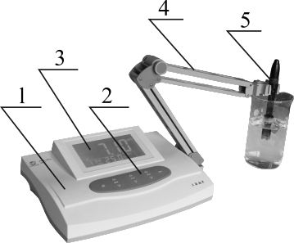
1. Main frame
2. Panel
3. Display screen
4. Electrode stand
- pH Electrode

6. pH electrode interface
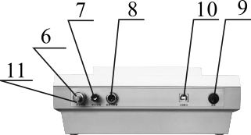
7. Reference electrode interface
8. Temperature sensor interface
9. Power switch
10. Power outlet
11. Q9 short-circuit plug
(installed on pH electrode interface)

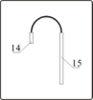
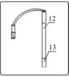
12. E-201-C model pH Electrode
13. Protection cover of electrode
14. RS765-3T interface
15. Temperature sensor

3. 1 Components Installation

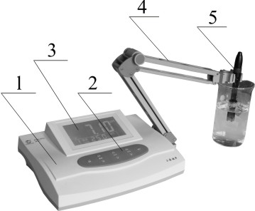

a) Fix the electrode stand (4) on the right side of pH meter and tighten
the bolt.
b) Place the pH Electrode (12) and Temperature sensor (15) on the
electrode stand(4).
c) Take the protection cover (13) from pH Electrode (12) and move the
rubber cover on the upper of pH electrode, make the hole exposed.
d) Wash the pH electrode with distilled water.

- pH 9.18 solution: Dissolve 3.80 borax in 1000ml high-purity
deionized water.
NOTE: Boiled the 1000ml high-purity deionized water for 15~30 min
before preparing Solution 2 and Solution 3 to remove Carbon
dioxide. Keep the deionized water away from air when cooling,
in case Carbon dioxide polluted it.
- Maintenance of Electrode
- Calibrate the electrode with standard buffers before testing, It is
muchbetter that the pH value of standard buffers close to the test
solution.
2. Take the protection cover of electrode away, keep the glass bulb of
electrode away from hard stuffs. Any breaking or scuffing will make
the electrode failure.
- Cover the electrode with protection cover after testing. Put some
external reference fluid to keep the glass bulb moist. Don’t dip the
electrode in the distilled water for long time.
- The external reference fluid of pH electrode is 3mol/L KFL
solution. Put the fluid in the protection cover from the hole on the
upper of the electrode.Cover the hole with protection cover(rubber
cover), in case the fluid try.
5. Keep the electrode interface dry, in case the short circuit.
6. Please use the electrode supported with equipment .
7. Don’t dip the electrode in distilled water, protein solution, acid
fluoride solution for long time.
8. Keep the electrode away from organic oil.
9. If the slope of electrode reduced after using for a long time. Dip the
Lower of electrode in 4%HF (Hydrofluoric acid) for 3~5s, then
clean it with distilled water, that dip it in 0.1mol/L HCL solution.
Then you can reuse it.
g) When test the mV of the pH electrode, connect the Q9 plug(11) to
the pH electrode interface(6),connect the pH electrode cable to the
Q9 plug;Or use electrode converter, connect converter to the
potential electrode interface (6), then connect the metallic electrode
to the other head of converter. Connect the reference electrode to the
reference electrode interface(7).
- Maintenance of Equipment
pH meter has high input impedance. It is very important to use correctly
and maintain it frequently.
- pH electrode interface(6) should keep dry and clean. Connect the
Q9 plug to the interface(6) to prevent the moisture and dust when it
laid up.
- Keep the electrode converter(optional) away from the moisture
and dust.
- Make sure the lead of the electrode unmoved when testing,
otherwise the value is not stable.
(4) Make sure the plug earthed.
(5) Equipment use MOS integrated circuit. Make sure the electric
Soldering iron earthed when repairing.
(6) Make sure the standard solution is correct, otherwise the testing
result will be wrong.
- Preparation of Buffers
1.pH 4.00 solution: Dissolve 10.12g GR Potassium hydrogen phthalate
in 1000ml high-purity deionized water.
2.pH 6.86 solution: Dissolve 3.387g GR Monopotassium phosphate,
3.533g Monosodium orthophosphate in 1000ml high-purity deionized
water.

- Operating
4. 1 Operation Panel
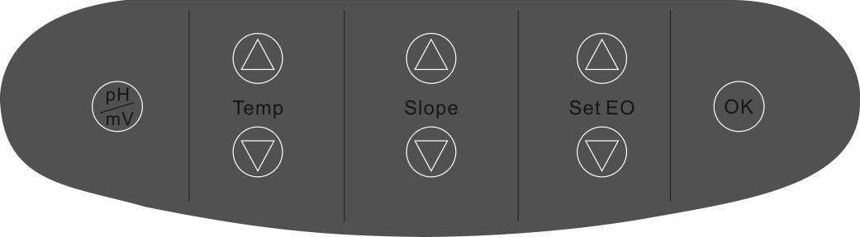
Key | Meanings
 | Testing mode |  | Switch“pH”mode and "mV"mode
 | Setting mode |  | Cance current setting, back to  testing mode
 | Confirm the value and save
 | Setting EO | Press "△" |  | EO rise
 |  | Press "▽" |  | EO reduce
 | Setting Slope | Press "△" |  | Slope rise
 |  | Press "▽" |  | Slope reduce
 | Setting Temp | Press "△" |  | Temperature rise
 |  | Press "▽" |  | Temperature reduce
4.2. Operation

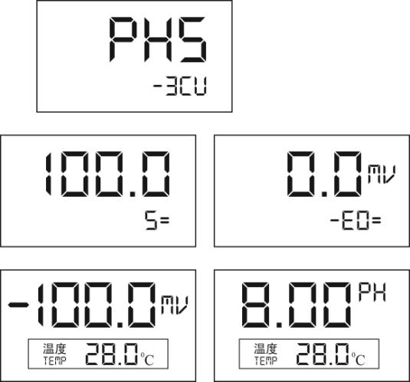
1.Plugging the pH meter and ture on. It shows"PHS-3CB"the model of the pH meter.

- Show the Slope and EO calibrated last time.

- Enter into the testing mode, show the current mV or pH.

In testing mode, press “pH/mV”can switch the mV and pH.
Press “Temp” to set the current temperature.
Press “Set EO” or “Slope” to calibrate the current EO and Slope.
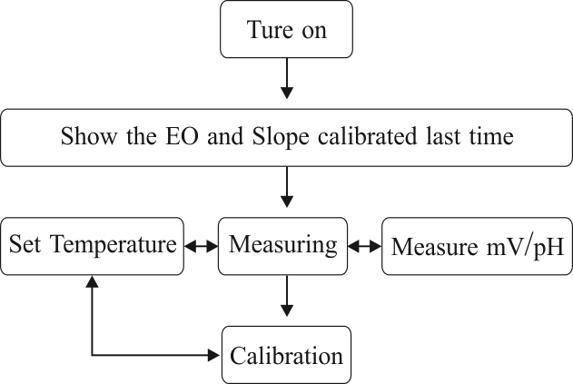

Flowchart of Operating
Calibrating the equipment before testing.
(1) The test solution and the calibration solution should have the same
temperature or the equipment has a temperature sensor:
- Wash the pH electrode with distilled water, then wash it again with test
solution;
b) Dip the electrodes(pH electrode and temperature sensor) into the test
solution. Stirring the test solution with glass rod. Show the pH value of the
test solution
- The test solution and the calibration solution are at different temperatures
or the equipment doesn’t have a temperature sensor:
- Wash the pH electrode with distilled water, then wash it again with test
solution;
b) Measure the temperature of the test solution with thermoment.
c) Press“Temp”, show the temperature of the test solution. Press “OK”..
d) Dip the electrode into the test solution, stirring the test solution with
glass rod. Show the pH value of the test solution.
4.5.2 mV Testing
a) Clasp the pH electrode and reference electrode (Optional) on the
electrode stand ;
b) Wash the electrodes with distilled water, then wash it again with
test solution ;
c) Connect the pH electrode to the pH electrode interface(6) ;
d) Connect the reference electrode to the reference electrode
interface(7) ;
e) Dip the pH electrode, reference electrode and temperature sensor
into the test solution, stirring the solution, show the mV value of the
electrode and “±” pole.
f) If the test subject is over the testing range of the equipment, it will
show "over";

c) As same as step( b),wash the electrodes again. Dip the electrodes
into the standard buffer 2( pH=9.18pH ), press"Slope"after the
reading stable, then press"OK".The equipment recognize and show
the pH value( 9.18pH ).
d) Press “OK”, confirm and save the data, Show the reading of slope
and EO.Then back to the testing mode.
e) If you use non-standard buffer solution, press “Set Eo△”or “Set
EO▽” to set the reading, make pH value as same as the standard
one in current temperature, then press “OK”.

If you need 3 point calibration,test the standard buffer 3 according to the steps of 2 point calibration.

4.4.3 Slope Restoring
The slope may be not correct because of some reasons, such as point
interruption. (The equipment shows last slope data of the electrode
when turned on ).
There are 2 ways to restore the slope.
A: Re-calibrate the slope according to the 2 point calibration.
B: Press“OK”and hold, then turn on the equipment. It shows
“-1888” and flicker 3 times, that means the system is resetting.
Then move the finger away from “OK”, back to the testing
Mode.

4.5 Testing
4.5.1 pH Testing

- Please make surehe electrodes or the Q9 short-circuit
plug (11) connect to the electrode interface (6)
before turning on.
- Connect the Q9 short-circuit plug to the electrode
interface(6),even you don't use it.
3. Warm up the equipment for over 0.5h before using.

4.3. Temperature Setting
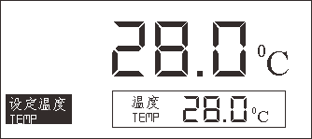
3CU has temperature-compensation function, it can set temperature automatically. If you need set the temperature by hand.

Press "Temp△"or "Temp▽" to set the temperature. It is the temperature of the test solution. Press"OK", confirm and save the value. Press"pH/mV" to exit and back to the testing mode.

4.4. Calibration
Calibrate the equipment before using. It's better to Calibrate it every day.It can recognize 4.00pH,6.86pH,9.18pH 3 standard buffers automatically.Only need to press"Set EO"or "Slope"then press "OK"to finish the Calibration with these 3 solutions.Press"Set EO"to do the 1 point Calibration;Press"Slope"to do the 2 point Calibration.To other non-standard buffers, set the pH value as same as the value of solution in current temp,then press" OK"

4.4.1 1 Point calibration
This is an easier calibration when you do low requirement testing. Only use 1 kind standard buffer to set EO and the slope is 100.0% as default.
NOTE:The new calibration data will cover the last data automatically, slope is 100.0%
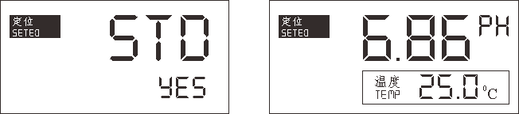
a) Wash the electrode with distilled water in measuring mode.
Then dip the pH electrode into the standard buffer.(e.g. pH=6.86pH
buffer solution);
b) Put the temperature sensor into the buffer, compensating the
temperature automatically;
c) Press"Set EO" after the reading stable, show"STD YES". Press,enter
the 1 point calibration mode.Press"pH/mV", exit calibration and
back to the testing mode.
In calibration mode, the equipment can recognize the standard pH
of solution in current temperature automatically.
At this moment, the pH reading maybe different from the one in
testing mode. Press”OK”,confirm and save the data and show the
slope and EO,then back to the testing mode.
If you need to quit the calibration mode, press"pH/mV",exit
calibration and back to the testing mode.
d) If you use non-standard buffer solution, press"Set EO△",or "Set
EO▽"to set the reading, make pH value as same as the standard one
in current temperature, then press"OK".

1. When use non-standard buffers to calibrate
the pH electrode,you have to know thestandard pH
value in different temperatures.
- Advice: Calibrate the electrode before every single
testing. The calibration data will cover the last one.
- After 1 point calibration, the equipment will delete
the last calibration data automatically and the slope
is 100.0%.

4.4.2 2. Point calibration
2 point calibration is used to calibrate the slope of electrode.
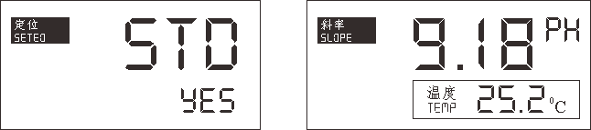
a) Prepare 2 standard buffers.(e.g.: 4.00pH, 9.18pH, etc.)
b) Wash the electrodes with distilled water in testing mode.Dip the
electrodes ( pH electrode and temperature sensor ) into the buffer
1( pH=4.00pH ),temperature compensated automatically.Press"Set
EO"after the reading stable, press"OK"enter the 1 point calibration
mode. Equipment recognize and show the pH value is 4.00pH in
current temperature, then press"OK",save the data and back to the
testing mode.

