INSTRUCTIONS
FA/JA ELECTRONIC BALANCE
OPERATION

6） In the gravity mode:
Push the “tare” button ,the balance comes back to the weighing mode ,and shows the weight value.
Push the “unit” button ,to select different measuring mode.
Notice: when the balance display gravity, only the tare, unit, print button can be used.
Ⅴ、 gravity measuring error
1） When the balance display ERR under gravity measuring, you can make the balance back to the weighing mode by pushing the tare button, at the same time, the balance shows the weight.
Notice: after gravity error, just the TARE and OFF button can be used.
Ⅵ、count button:
1）Used as counting under weighing mode
2）Used as calculating and remembering function
Ⅶ、the instrument has the function of mode remembering
9.Random Accessories
1. 200g(and100g)calibration weights 1 piece
2. Wire with both-side plug 1 piece
3. Weights tweezers 1 piece
4. Handkerchief 1 piece
5. Operation manual 1 piece
6. Certificate 1 piece
7. Brus 1 piece
8. Nipper 1 piece

15

CONTENT

1. Outline (01)
2. Main technical Specifications (02)
3. Drawings for Balance Installation (04)
4. Operating (06)
A. Preparation (06)
B. Operation (06)
C. Start (06)
D. RNG Weighing (07)
E. UNT Unit Change (08)
F. INT Integrating Time Adjustment (08)
G. ASD Sensitivity Adjustment (08)
H. PRT Output Mode Setting (09)
I. COU Count Function (09)
J.Weighing,Taring,Add Objects,Read Devitions (10)
5.MaintenanceandTroubleshooting (11)
6. Dats InterfaCe (12)
7. Serial Single ( RS232C ) (13)
8. Density balance operation (14)
9. Random Accessories (15)

1. Outline
Thank you for busying the type FA/JA series electronic balance frorn our company. For correct and safe fixing and operation, as well as full function apply, we suggest that you should read tha users’ manual before using it Thanks.
The balance is multifunctional electronic balance using MCS-54series SCM This balance has gram, cant, ounce for users to select (cant and ounce for export) besides having automatic calibration, integral time adjustment and stability adjustment functions This balance has RS232C data serial duplexing port to connect with microcomputer and serial port punter This balance is used for fast exact weight measuring widely in enterprise, university, graduate school lab as an ideal lab instrument.
Finally, after reading the manual, please keep it carefully for referring.

1
8.Density Balance Operation
ⅠMeasuring mode selection: press the “UNT” button immovably, the balance will show the following in turn
-UNT-o

-UNT-g

-UNT-cs

-UNT-ct

-UNT-oz

-UNT-ozt

-UNT-cs： measuring the liquid gravity mode
-UNT-os： measuring the solid gravity mode
-UNT-g、-UNT-ct、-UNT-oz、-UNT-ozt： All the weighing mode, show the model upper right at the same time
gs：gram； ct：carat； oz：ounce； ozt：0.911 ounce；
cs：liquid gravity； o：Solid gravity
Ⅱ measuring the liquid gravity
1） put the thermometer on the wall of the beaker
2） put the beaker on the center of the bedplate
3) Put the “tare” button to zero the balance ,put the liquid component
(platinum ,plumb) wire on the fix support
4） Inject the sample in the beaker(immerge the plumb completely),push the “count” button ,the balance shows “---------“.the balance will show the gravity value directly after the sensor data is stable
Ⅲ、 solid gravity measuring
1） put the thermometer on the wall of the beaker
2） put the beaker on the center of the bedplate
3） Inject the water in the beaker, make sure the sample can be immerged in the water completely
4） Put the basket on the fix support, make sure it does not touch the beaker and thermometer
5）Tare the balance, put the sample on the scale on the support ,push the “count” button ,the balance shows “————”,when the instrument shows the value again, put the sample in the basket slowly ,then the balance shows “————” again ,then ,the instrument shows the gravity value directly3 14
6.Date Interface
Date interface adopts the standard 9-core RS-232C sDcket. The date interface is provided with RS232C universal two - way serial interface, which can be connected to the microprocessor and various printers.No.Standard Parallel Output.The pin and the corresponding signanls are as follows:
PIN SIGNAL ILLUSTATE
1 SI input signal
2 GND
3 SO serial output signal(baud rate is 1200)
4 GND
7.Serial Single (RS232C)
The connection method between the scale and computer serial port is as follows:
Computer(9pins) Scale(9pins)
2 -------------------------- 2
3 -------------------------- 3
5 -------------------------- 5
1) The baud rate of the serial port of scale is 1200.
2) The date format is 10digits, one start digit is(0) ,8 digits are date positions (ASCII Code,low digits in the front),1 stop digit.
3) No odd-even check
4) The date will be output continuously without any special reading commands A detailed output frame is as follows:

1 | 2 | 3 | 4 | 5 | 6 | 7 | 8 | 9 | 10 | 11 | 12 | 13 | 14 | 15 | 16
Type | Space | */Space | +/- | Date | Date | Date | Dot | Date | Date | Date | Date | Unit1 | Unit2 | CR | LF

13

2.Main technical Specifications
Model | FA1004b | FA1104b | FA1604b | FA2004b | FA2204b
Accuracy Degree
Weighing Range(g) | 100 | 110 | 160 | 200 | 220
ReadlngAccuracy(mg) | 0.1 | 0.1 | 0.1 | 0.1 | 0.1
Taring Range(g) | 0~100 | 0~110 | 0~160 | 0~200 | 0~220
Repeatability Standard Deviation(g) | ±0.0002 | ±0.0002 | ±0.0002 | ±0.0002 | ±0.0002
Linear Error(g) | ±0.0005 | ±0.0005 | ±0.0005 | ±0.0005 | ±0.0005
Stable Time (Typical)(s) | ≤6 | ≤6 | ≤8 | ≤8 | ≤8
Integrating Time (Adjustable)(s) | 2/4/8 | 2/4/8 | 2.5/5/10 | 2.5/5/10 | 2.5/5/10
Pan Dia.(mm) | Φ80
Overall Dimensions (mm) | 360×217×345
Net Weight(kg) | 6.8
Power Supply
Power Consumption  (V .A) | 15
Auto-Cal Weight  Range(g) | 100 | 100 | 160 | 200 | 220
Warm-upTime(mis) | 180 | 180 | 180 | 180 | 180
2
Model | JA1003b | JA2003b | JA300b | JA5003b | JA10003
Accuracy Degree
Weighing Range(g) | 100 | 200 | 300 | 500 | 1000
ReadlngAccuracy  (mg) | 1 | 1 | 1 | 1 | 1
Taring Range(g) | 0~100 | 0~200 | 0~300 | 0~500 | 0~1000
Repeatability Standard Deviation(g) | ±0.001 | ±0.001 | ±0.001 | ±0.001 | ±0.001
Linear Error(g) | ±0.002 | ±0.002 | ±0.002 | ±0.002 | ±0.002
Stable Time (Typical)(s) | ≤6 | ≤6 | ≤6 | ≤6 | ≤6
Integrating Time (Adjustable)(s) | 2/4/8 | 2/4/8 | 2/4/8 | 2/4/8 | 2/4/8
Pan Dia.(mm) | Φ80 |  |  | Φ110
Overall Dimensions (mm) | 360×217×345
Net Weight(kg) | 6.8
Power Supply
Power Consumption  (V .A) | 15
Auto-Cal Weight  Range(g) | 100 | 200 | 200 | 500 | 1000
Warm-upTime  (mis) | 60 | 60 | 60 | 180 | 180
Note:The balance is turned on when the power is on. The panel switches activate display only. The power plug should be removed if the balance is not used for a long time.If it is used daily, the power needn’ t be turned off.The only thing needs to be done is to turn off the display.It is not necessaly to warm up due to the power on,so it can be used at any time.(“Aong time”means more than 5 days.)
3
SN | TROUBLE | CAUSE | REMEDY
6 | Display remains at a certain digit or indicates nonsense symbol | ·Instant interference  ·Wreng line voltage | ·Turn on the balance once again or replug the power cord  ·Chang to normal line voltage
7 | The stable mark “0”on the left of the display doesnt go out | ·A higher balance sensitivity  ·undesirable environment such as strong air flow or vibration | ·Set to lower sensitlivity  ·Improve the environment
8 | Remain at Waiting Status———— | ·Thr balance position is not correct, e.g. With strong air flow, vibration or great fluctuation of room temp.  ·The selected sensitivity is toohigh | Improve the environment ASD-3
9 | Cal Err  Displays | ·There is an object on the pan befpre calibration  ·not clear before calibration  ·Depress CAL before the | ·Take away the object,clear and recalibrate  ·Clear and recalibrate
10 | Err-1 Err-2  Display | ·Instant interference  ·Something wrong with thebalance | ·Ture on the balance once again  ·Send it to the service center
11 | The weighing unit on the right dosent display | ·not calibrated  ·The calibrated number in the internal memory of the balance has been erased | ·Calibrate the balance
12 | Cou-Err Display | ·No Constant be set before operating counting function  ·Overload when setting constant  ·Underload when setting constant | ·Set average number before operating counting function

12

UNLOAD
Loose the screwn of the bottom cover,raveal the hook.Put the balance on a woking table with a hole. Level and calibrate the balance .An object can be weighed with the hook.
5.Maintenance and troubleshooting
MATNTENANCE OF THE BALANCE
The batance should be used carefully.Clean the pan and the case frequently with soft cloth and toothpaste.Don,t wipe the batance with strong agent.
TROUBLESHOOTING
SN | TROUBLE | CAUSE | REMEDY
1 | No ligbt on Display | ·Power is not on  ·Disptsy switch is not on  ·Instant interrference | ·Check and turn it on again  ·Depress ON button  ·Switch on again and replug power
2 | Displsy the upper hstf only | ·Overload  ·The calibration in the  intemal memory may ba damaged  ·The pan is not installed correctly | ·Reduce the load immediately  ·Recalibrate according to the above procedures. About 8 seconds after the standard weight has been put on,the calibrated result may be displayed. A certain stable time is necessary.  ·Take out the pan and reinstall it.
3 | Display the lower half Only——— | ·without pan,too light  ·he pun is not installed correctly | ·Reinstall the pan
4 | The weighing result is not stable (date changed swiftly) | ·due to air flow  ·the working table it net stable  ·the integrating time is too short  ·Roam tetnpeealtsre flucttsates | ·Cheek the windproof cover tu see if it is closed.  ·Change to a longer integrating time
5 | The retult is not correct | ·not zeroing before weighing  ·Use the balance without calibration or the cal weight is not accurate  ·The line vollage is too low or net correct | ·Depress TAR button  ·Reclibrate  ·Change to the correct voltage

11

3.Drawings for Balance Installation

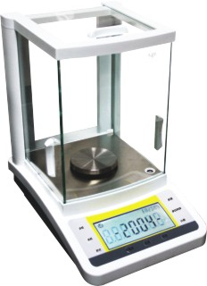

3
2 1.panel
2.gradienter
3.scalepan

1

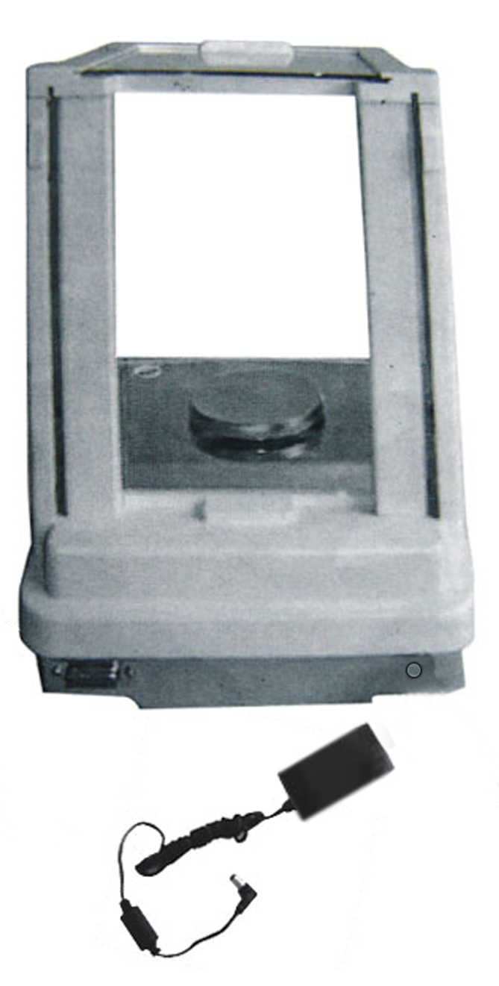

1 1. Data Interfale
2. Transformer
3.Electrical Outlet
3
2

4

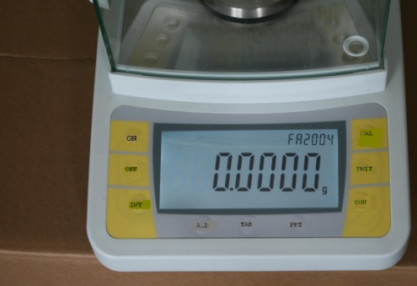

Single Measuring Range

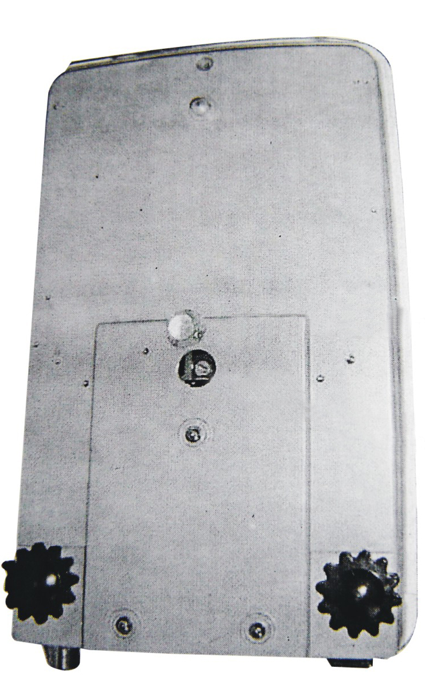

1

2

1.Cover Honrd 2..Pothook

5

J . Weighing ,Taring ,Add Objects ,Read Devitions
WEIGHING
After the selection of the above modes(all the modes can be used for weighing after the power is off ,due to the memorv function of the balance ),depress TAR,zero will display.Put the object to be
weight on the pan.When the number is stable, i.e.“0”on the left of the displaygoes out,the number
display goes out,the number displayed will be the weight of the object.
TARING
Put the container on the pan, the weight will display.Depress TAR,zero displays. That is taring. Put the objects to be weighed into the container, the value displayed is the net weight of the object to be weighed
ACCUMULATIVE WETGHTNG
Pat the objects be weighed on the pan one by one with taring method and tare and clear for each one.Take away all the objects to be weighed , the absolute value display in the total weight of the objects to be weighed.
ADD OBJECTS
Set the mode of INT-0 and put the container on the pan , then tare. Add the objects to be weighed (liquid or loose objects) into the container one by one the continuous reading value can be obtained quickly. when the added objects reach the required“0”on the left of the display goes out and the number display is the weighing value required by the user. When adding the mixed objects.the net weight of each object can be measured by taring method.
PEAD DEVIATIONS
Put the reference weight(or rample) on the pan and tare . then take off the reference
weight the negative value of the weight dispIay.Put the object to be weighed on the pan.The corre sponding plus or minus deviution will display, comparing the weighed object with the reference weight
10
H . PRT Output Modde setting
Deprss PRT and hold there will be four modes displayed circularly for user to select at will..
PRT-O is the mode of indefinite time output ; slghtly depress PRT once ,the weighing
result will be.out on the output interface once.
Attention: At this time you should depress the button slisghtly and quickly, otherwise, the next output mode will be displayed
PRT-1 output once every half a minute
PRT-2 output once every minute
PRT-3 output once every two minutes
--PRT---0
--PRT---1

--PRT---2

--PRT---3

The setting of PRT is the same as RNG
I. COU Count Function
The balance has a function of counting. The average number are 5,l0,25and 50,total of four .The Setting of Range of Average Numbers
Only depress COU and hold ,the display will be circulating continuously as the following.
COU—00

COU—05

COU—10

COU—25

COU—50

It means the average value of (5,10,25,50)objects respectively
if a normal weighing function is required ,release when COU-00 display, and waiting status“……” will be indicated ,at last0.000g weighing status will be indicated .lf the average value of five is required, release when COU-5 displays, then put5 objectson the pan Depress CAL once again. “……”waiting status displays ,and about several seconds later,5 will be displayed. Take away the objects
to be weighed ,zero displays. At that time the counting of the same objects to be weighed can be done (Attention :the weight of the objects to be weighed must not be greater than the maximum weighing rang of the balance). If you average over 10,25 even SO objects ,then the accuracy of counting will be higher Depress TAR,“0”will be indicated in the display and counting can be done at that time.

9
4. Operating
A. Preparation
·Unpack the box and remove all packings . Take out buffer sponge in the wind proof cover and install pans.
·Put the balance on a stable working table free form vibration, sunshine and air flow.
·Ambient temperature:
20℃±5℃ for the first class balance with a fluctuation of temperature not greater than 1℃/h;
20℃±7.5℃ for the second class balance with a fluctuation of temperature not greater than 5℃/h;
·Relative humidity:50%-75% for the first class lance, 50%-80% for the second class balance.
·Working voltage:
B. Operation
·Check the level meter before opertion,lf the bubble is not in the center, adjust the level legs to make the bubble in the center..
·The balance adopts soft touch buttons , so it can be controlled with multikey boards .lt is easy to operate .Function change and selection can be realized simply by depressing the corresponding buttons.
C. Start
·Select an appropriate line voltage and set the voltage switch to the corresponding position.
·Turn the power on and the balance is ready to run(but the display doesn’t work ),normally one hour after power is one , the display can be operated.
±  。 | 8888888 | FA2004b  %  g
Function of the keyboard:
“ON”DISPLAY ON

Depress slightly the button “ON” the display will be lighted..
Check the function of the display ,about 2 seconds later ,the model of the balance will be displayed.
—2004—
For example:
then the weighing mode.

6
0.0000g or 0.000g
0.0000g

0.0000g
or
“OFF” DISPLAY OFF
Depress slightly the button“OFF” ,the display will go out. If the balance will not be used for a long time ,the power plug should be taken off.
“TAR” Clear and Tare
Put the container on the pan,the weight of the container should be displayed:
+18.9001g

Depress “TAR” button,the display will go out and the display will be all zeroes. Taring ia completed:
0.0000g

When the container is removed, a negative value of the container weight will be displayed.
-18.9001g

Depress“TAR”again, the display will be all zeroes,i.e.the balance clears.
0.0000g

D.Balance calibration
the balance should be calibrated after a long period of storage, movement, change of environment or in order to obtain precise measurement.
Preparation for the balancce calibration:
(a).Take away all the objects to be weighed on the pan. Depress slightly TAR for clear thebalance.
(b).Depress slightly CAL.CAI-200 will be on the flash-display. Therefore, put the prepared 200g standard weight on the pan ,the flash-display will stop.
After several seconds, 200.000g will be displayed. Remove the calibration weight,the display should indicate 0.000g. if not clear once again and repeat the above procedures. (Attention:More than two times of calibration are mcommended in order to get accurate result.)
。 | CAL-200 | FA2004b

7
Notice: 1,the TAR button can stop the calibration at any time
2,depress the TAR button until displaying 0.0000g before calibrating

E.UNT Unit Change
If the accuracy of the reading needs to be 0.1mg release when the display is mg-60; and the appears waiting state...,the weighing state will be shown at last.
Depress ERY button and hold until the display is shown as the following figure circulating continuously.
—Unt— g

—Unt— ct

—Unt— oz
—Unt— ozt

“g” means the value is expressed in gram .“ct” means the value is expressed in metric carat. “ozt” means the value is expressed in. The unit will be set same as RNG.

F. INT Integrating Time Adjustment
Four modes of integrating time can be selected circularly as shown in the figure
--INT---0
-- INT --1
--INT---2
--INT---3

The corresponding integrating time is as follows:
INT-0 fast, NT-1 shorter, INT-2 short, INT-3 longer
The selection of the integrating time will be the same as RNG
G. ASD Sensitivity Adjustment
Same as INT interrating time adjustment button: there are four circulating modes
provided for sensitivity adjustment.
--ASD--0
-- ASD--1
--ASD--2
--ASD--3

ASD—0 the highest ASD—1 high ASD—2 higher ASD—3 low
ASD-0 is used for test run and not to be usd by the users.
The selection of sensitivity is the same as RNG.
Here is a list of ASD usesd with INT for user’s reference only.
The fastest weighing: INT-1 ASD-3
Normal: INT-3 ASD-2
With undesirable environment INT-3 ASD-3 8

