INSTRUCTIONS
FA/JA-C ELECTRONIC
BALANCE OPERATION

interface is provided with RS232C universal two - way serial interface, which
can be connected to the microprocessor and various printers. No. Standard Parallel Output. The pin and the corresponding signals are as follows:
PIN SIGNAL ILLUSTATE
2 SI RXD input signal
3 SO TXD serial output signal(baud rate is 1200)
5 GND

7.Serial Single (RS232C)
The connection method between the scale and computer serial port is as follows:
Computer(9pins) Scale(9pins)
2 2
3 3
5 5
1) The baud rate of the serial port of scale is 1200.
2) The data format is 10digits, one start digit is(0) ,8 digits are data positions (ASCII Code, low digits in the front),1 stop digit.
3) No odd-even check
4)The data will be output continuously without any special reading commands A detailed output frame is as follows:

1 | 2 | 3 | 4 | 5 | 6 | 7 | 8 | 9 | 10 | 11 | 12 | 13 | 14 | 15 | 16
Type | Space | */Space | +/- | Data | Data | Data | Dot | Data | Data | Data | Data | Unit1 | Unit2 | CR | LF
8.Random Accessories

1. 200g(and100g)calibration weights 1 piece
2. Wire with both-side plug 1 piece
4 . Weights tweezers 1 piece
5. Handkerchief 1 piece
6. Operation manual 1 piece
7. Certificate 1 piece

CONTENT

1. Outline (1)
2. Main technical Specifications (2)
3. Drawings for Balance Installation (3)
4. Operating (4)
A. General (4)
B. Preparation (4-5)
C. Operation (5)
D. UNT Unit Change (5)
E. INT Integrating Time Adjustment (5-6)
F. ASD Sensitivity Adjustment (6)
G. Balance Calibration (6-7)
H. PRT Output Mode Setting (7)
I. COU Count Function (7-8)
J. Weighing, Taring ,Add Objects, Read Deviations (8-9)
5. Maintenance and Troubleshooting (9-10)
6. Data Interface (10-11)
7. Serial Single ( RS232C ) (11)
8. Random Accessories (11)

1.Outline
Thank you for buying the type FA－C series electronic balance from our company. For correct and safe fixing and operation, as well as full function apply, we suggest that you should read the users’ manual before using it Thanks
The balance is multifunctional electronic balance using MCS-54 series SCM This balance has gram, carat, ounce for users to select (carat and ounce for export) besides having automatic calibration, integral time adjustment and stability adjustment functions This balance has RS232C data serial duplex port to connect with microcomputer and serial port printer This balance is used for fast exact weight measuring widely in enterprise, university, graduate school lab as an ideal lab instrument.
Finally, after reading the manual, please keep it carefully for referring.

SN | TROUBLE | CAUSE | REMEDY
6 | Display remains at a certain digit or indicates nonsense symbol | ·Instant interference  ·Wrong line voltage | ·Turn on the balance once again or replace the power cord  ·Chang to normal line voltage
7 | The stable mark “0”on the left of the display does not go out | ·A higher balance sensitivity  ·undesirable environment such as strong air flow or vibration | ·Set to lower sensitivity  ·Improve the environment
8 | Remain at Waiting Status———— | ·The balance position is not correct, e.g. With strong air flow, vibration or great fluctuation of room temp.  ·The selected sensitivity is too high | Improve the environment ASD-3
9 | Cal Err  Displays | ·There is an object on the pan before calibration  ·not clear before calibration  ·Depress CAL before the | ·Take away the object, clear and recalibrate  ·Clear and recalibrate
10 | Err-1 Err-2  Display | ·Instant interference  ·Something wrong with the balance | ·Turn on the balance once again  ·Send it to the service center
11 | The weighing unit on the right does not display | ·not calibrated  ·The calibrated number in the internal memory of the balance has been erased | ·Calibrate the balance
12 | Cou-Err Display | ·No Constant be set before operating counting function  ·Overload when setting constant  ·Underload when setting constant | ·Set average number before operating counting function
6.Data Interface
Data interface adopts the standard 9-core RS-232C jack. The data
weight the negative value of the weight display . Put the object to be weighed on the pan. The core sponding plus or minus deviation will display, comparing the weighed object with the reference weight
UNLOAD
Loose the screw of the bottom cover, reveal the hook. Put the balance on a working table with a hole. Level and calibrate the balance .An object can be weighed with the hook.
5.Maintenance and troubleshooting
MATNTENANCE OF THE BALANCE
The balance should be used carefully. Clean the pan and the case frequently with soft cloth and toothpaste. Do not wipe the balance with strong agent.
TROUBLESHOOTING
SN | TROUBLE | CAUSE | REMEDY
1 | No light on Display | ·Power is not on  ·Display switch is not on  ·Instant interference | ·Check and turn it on again  ·Depress ON button  ·Switch on again and plug power again
2 | show the upper half only | ·Overload  ·The calibration in the  internal memory may be damaged  ·The pan is not installed correctly | ·Reduce the load immediately  ·Recalibrate according to the above procedures. About 8 seconds after the standard weight has been put on, the calibrated result may be displayed. A certain stable time is necessary.  ·Take out the pan and reinstall it.
3 | Display the lower half Only——— | ·without pan, too light  ·he pun is not installed correctly | ·Reinstall the pan
4 | The weighing result is not stable (data changed swiftly) | ·due to air flow  ·the working table it net stable  ·the integrating time is too short  ·Roam temperature influence | ·Cheek the windproof cover tu see if it is closed.  ·Change to a longer integrating time
5 | The result is not correct | ·not zeroing before weighing  ·Use the balance without calibration or the cal weight is not accurate  ·The line voltage is too low or net correct | ·Depress TAR button  ·calibrate  ·Change to the correct voltage
2.Main technical Specifications
Model | FA1004C | FA1104C | FA1204C | FA1604C | FA2004C | FA2104C | FA2204C
Accuracy Degree | 
Weighing Range(g) | 0~100 | 0~110 | 0~120 | 0~160 | 0~200 | 0~210 | 0~220
Reading Accuracy(mg) | 0.1 | 0.1 | 0.1 | 0.1 | 0.1 | 0.1 | 0.1
Taring Range(g) | 0~100 | 0~110 | 0~120 | 0~160 | 0~200 | 0~210 | 0~220
Repeatability Standard Deviation(g) | ±0.0002 | ±0.0002 | ±0.0002 | ±0.0002 | ±0.0002 | ±0.0002 | ±0.0002
Linear Error(g) | ±0.0005 | ±0.0005 | ±0.0005 | ±0.0005 | ±0.0005 | ±0.0005 | ±0.0005
Stable Time (Typical)(s) | ≤6 | ≤6 | ≤6 | ≤8 | ≤8 | ≤8 | ≤8
Integrating Time (Adjustable)(s) | 2/4/8 | 2/4/8 | 2/4/8 | 2.5/5/10 | 2.5/5/10 | 2.5/5/10 | 2.5/5/10
Pan Dia.(mm) | Φ90
Overall Dimensions (mm) | 360×217×345
Net Weight(kg) | 6.8
Power Supply | 9.0V-12.0V、1000MA
Power Consumption  (V .A) | 15W
Auto-Cal Weight  Range(g) | 100 | 100 | 100 | 160 | 200 | 200 |  | 220
Warm-up Time(mis) | 180 | 180 | 180 | 180 | 180 | 180 |  | 180
Note: The balance is turned on when the power is on. The panel switches activate display only. The power plug should be removed if the balance is not used for a long time. If it is used daily, the power needn’ t be turned off. The only thing needs to be done is to turn off the display. It is not necessary to warm up due to the power on, so it can be used at any time.(“long time” means more than 5 days.)
3.Drawings for Balance Installation
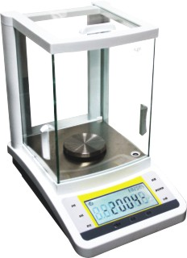

3
2 1.panel
2.gradienter
1 3.scalepan

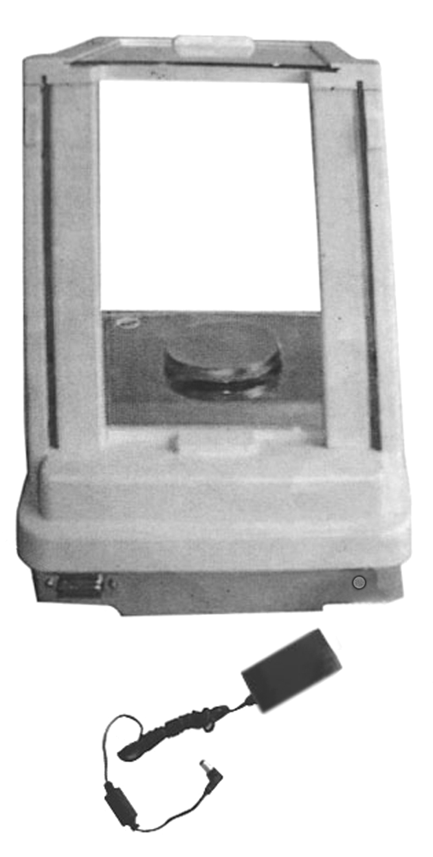

1 1. Data Interface
2. Transformer
3.Electrical Outlet
3
2
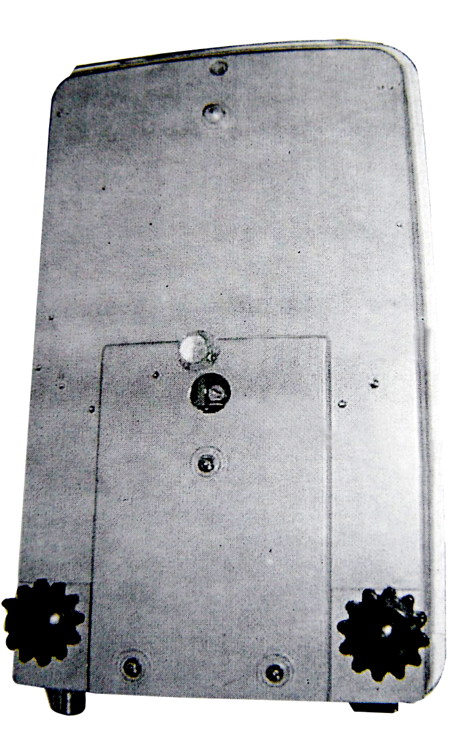
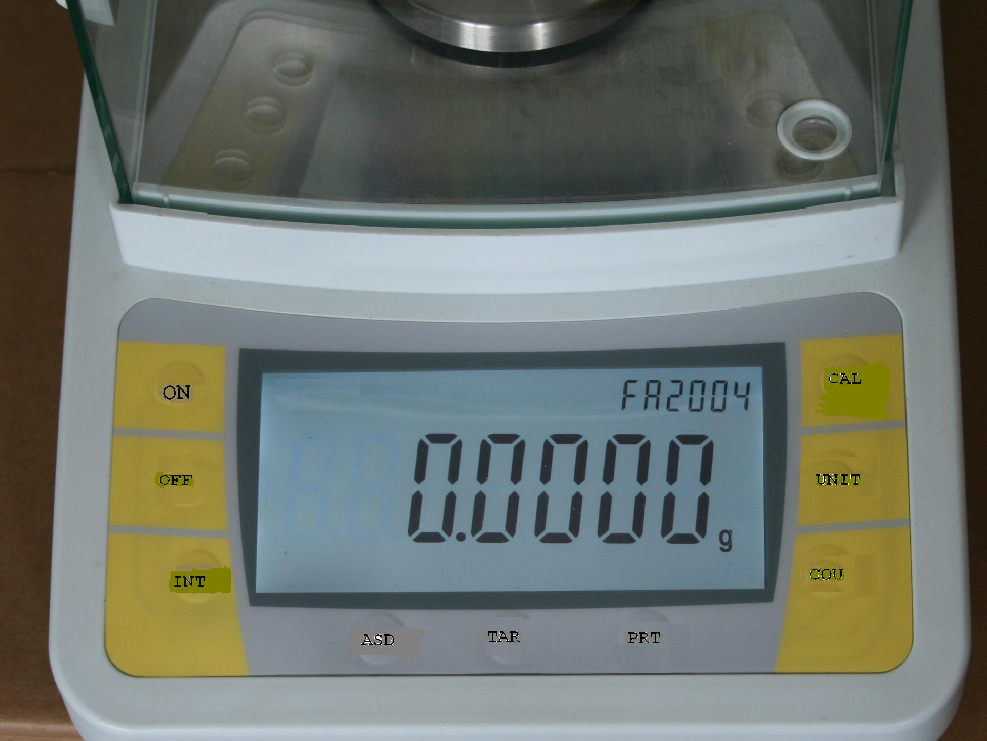

1
2

Single Measuring Range 1.Cover Board
2..Pothook

if a normal weighing function is required ,release when COU-00 display, and waiting status“……” will be indicated ,at last0.000g weighing status will be indicated .lf the average value of five is required, release when COU-5 displays, then put5 objection the pan Depress CAL once again. “……”waiting status displays ,and about several seconds later,5 will be displayed. Take away the objects to be weighed ,zero displays. At that time the counting of the same objects to be weighed can be done (Attention :the weight of the objects to be weighed must not be greater than the maximum weighing rang of the balance). If you average over 10,25 even SO objects ,then the accuracy of counting will be higher Depress TAR,“0”will be indicated in the display and counting can be done at that time.
J . Weighing , Taring ,Add Objects ,Read Deviations
WEIGHING
After the selection of the above modes(all the modes can be used for weighing after the power is off ,due to the memory function of the balance ),depress “TAR”, zero will display. Put the object to be
weight on the pan. When the number is stable, i.e.“0”on the left of the display goes out, the number
display goes out, the number displayed will be the weight of the object.
TARING
Put the container on the pan, the weight will display. Depress TAR, zero displays. That is taring. Put the objects to be weighed into the container, the value displayed is the net weight of the object to be weighed
ACCUMULATIVE WETGHTNG
Pat the objects be weighed on the pan one by one with taring method and tare and clear for each one. Take away all the objects to be weighed , the absolute value display in the total weight of the objects to be weighed.
ADD OBJECTS
Set the mode of INT-0 and put the container on the pan , then tare. Add the objects to be weighed (liquid or loose objects) into the container one by one the continuous reading value can be obtained quickly. when the added objects reach the required“0”on the left of the display goes out and the number display is the weighing value required by the user. When adding the mixed objects. the net weight of each object can be measured by taring method.
READ DEVIATIONS
Put the reference weight(or sample) on the pan and tare . then take off the reference
weight (try your best to put the weight on the center of span),then the balance goes to the calibrating state. After several seconds, 200.000g will be displayed. Remove the calibration weight, the display should indicate 0.000g. if not clear once again and repeat the above procedures. (Attention: More than two times of calibration are recommended in order to get accurate result.)
Notice: 1,only the “CAL-E” means outside calibrating
2,you can stop the outside calibrating at will by press the “TAR” button. After that, the balance goes to the working state
H . PRT Output Model setting
Depress PRT and hold there will be four modes displayed circularly for user to select at will..
PRT-O is the mode of indefinite time output ; slightly depress PRT once ,the weighing
result will be. out on the output interface once.
Attention: At this time you should depress the button slightly and quickly, otherwise, the next output mode will be displayed
PRT-1 output once every half a minute
PRT-2 output once every minute
PRT-3 output once every two minutes
--PRT---0
--PRT---1

--PRT---2

--PRT---3

The setting of PRT is the same as RNG
I. COU Count Function
The balance has a function of counting. The average number are 5,l0,25and 50,total of four .The Setting of Range of Average Numbers
Only depress COU and hold ,the display will be circulating continuously as the following.
COU—00

COU—05

COU—10

COU—25

COU—50

It means the average value of (5,10,25,50)objects respectively

4.Operating
A. General
Get to know the FA/JA series balance: Different design, the same usage. FA/JA type balance provides the inside automatically calibrating. D=0.1mg.The range of weighing is from 10mg to 210g. This instrument has the function as weighing, taring, calibrating, counting, unit changing, stability setting, sensitivity setting, full scale taring, zero position adjusting and so on.
B. Preparation
·Unpack the box and remove all packing . Take out buffer sponge in the wind-proof cover and install the scale pan.
·The balance adopts soft touch buttons , so it can be controlled with key combnation boards . it is easy to operate .Function change and selection can be realized simply by depressing the corresponding buttons.
·Put the container on the pan, the weight of the container should be displayed:
·Put the balance on a stable working table without vibration, sunshine and air flow. Far away from the door, windows, radiator and the venthole of the air condition.
·Ambient temperature:
·All the balance has one level bleb and two level adjusting legs, adjusting the legs to make the bleb in the center to get the level
notice: a new placing the balance needs the level adjusting again
20℃±5℃ for the first class balance with a fluctuation of temperature not greater than 1℃/h;
·Relative humidity:50%-75% for the first class lance.
·Working voltage: 9.0V-12.0A、1000MA
a. plug the power adapter into the adapter jack, get the power by another side
b. the balance will have the post. the showing of “OFF”means the success of post
c. press the “on”button, after 30 minutes the balance will be turned on automatically
d. after the showing of model, the balance will do the inside calibrating automatically., then, the showing of “0.0000g”means the success of inside calibrating. the balance gets the working state
Note: when it is in the warming up state
Putting the tare button can open the machine without calibration
For example The working state
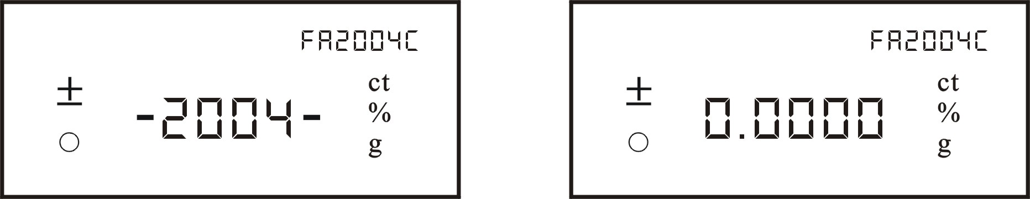
“OFF” DISPLAY OFF
Depress slightly the button“OFF” ,the display will be “OFF”.The balance goes into ‘SCREEN PROTECTION”station “TAR” Clear and Tare
C . Operation
Check the level meter before operation, lf the bubble is not in the center, adjust the level legs to make the bubble in the center..
+20.8001g

Depress “TAR” button, the display will go out and the display will be all zeroes. Taring is completed:
0.0000g

When the container is removed, a negative value of the container weight will be displayed.
-20.8001g

Depress “TAR” again, the display will be all zeroes, i.e. the balance clears.
0.0000g

D.UNT Unit Change
If the accuracy of the reading needs to be 0.1mg release when the display is mg-60; and the appears waiting state...,the weighing state will be shown at last.
Depress ERY button and hold until the display is shown as the following figure circulating continuously.
—Unt— g

—Unt— ct

—Unt— oz
—Unt— ozt

“g” means the value is expressed in gram .“ct” means the value is expressed in metric carat. “ozt” means the value is expressed in. The unit will be set same as RNG.
E. INT Integrating Time Adjustment
Four modes of integrating time can be selected circularly as shown in the figure
--INT---0
-- INT --1
--INT---2
--INT---3

The corresponding integrating time is as follows:
INT-0 fast, NT-1 shorter, INT-2 short, INT-3 longer
The selection of the integrating time will be the same as RNG
F. ASD Sensitivity Adjustment
Same as INT interrating time adjustment button: there are four circulating modes
provided for sensitivity adjustment.
--ASD--0
-- ASD--1
--ASD--2
--ASD--3

ASD—0 the highest ASD—1 high ASD—2 higher ASD—3 low
ASD-0 is used for test run and not to be used by the users.
The selection of sensitivity is the same as RNG.
Here is a list of ASD used with INT for user’s reference only.
The fastest weighing: INT-1 ASD-3
Normal: INT-3 ASD-2
With undesirable environment INT-3 ASD-3
G . BALANCE CALIBRATION
Normally, the balance should be calibrated after a long period of storage, movement, change of environment or in order to obtain precise measurement.
The balance has two kinds of balance
- inside calibrating
Take away all the objects to be weighed on the pan. press the “CAL” button until the ”CAL int” shows on the screen then relax button, the balance goes to the automatic inside calibrating state , when showing the “0.0000g”,that means the success of inside calibrating. The balance goes to the working state
Notice:1,only the “CAL int” means inside calibrating
2,after warming up for 30 minutes, the balance will go to the screen protection state ,if nothing is on the scale pan for 10 minutes, when press the “on” button to go to the working state, the balance will do the inside calibrating action automatically
B. outside calibrating
get the calibrating weight ready
Take away all the objects to be weighed on the pan , press the “CAL” button until the ”CAL -E” shows on the screen then relax button, the balance goes to the outside calibrating state, the “CAL-200”will be displayed sparking, put on the calibrating

