INSTRUCTIONS
MD Density Electronic Scale

MD electronic density scale is an intelligent scale made with highly-stable sensor and single-chip microcomputer. It has many functions, like multi-units conversion, counting, percentage, RS232, tare removal, self-calibration, memory, etc. It is precise, fast and stable, easy to operate, and multi-functional, and can apply to the fast weight and quantity measurements in manufacturing, agriculture, commerce and schools.

Technical Parameters:
Model | MD-100 | MD-200
Max. measurement range | 100g | 200g
division value | 0.01g | 0.01g
Display form for liquid density | δ | 20  20
Test liquid Max. density value | 2.000
Accuracy | 0.01
Plummet volume | 5cm³
Power supply | AC 220V 50Hz ， DC 6V~9V
Wattage | 1W

One: Preparation
1. Put scale on a stable and even place. Avoid vibration, direct sunray, airstream or strong electromagnetic wave disturbance.
2. Working environment:
temperature limits: 5°C ～35°C temperature fluctuation: ≤5°C/h
relative humidity: 50%～85%

Two: Start
1. Plug one side of adapter or power cord to scale power inlet, the other side to AC.
2. Turn on power switch. Display in order “8.8.8.8.8.8.”、“max measurement value”、
“-------”, and finally “0” or “0.0”or“0.00” or“0.000”measurement modes when stable.

Three: Calibration
1. Preparations before calibration
1）.Turn on power and warm up over 15 minutes
2）.No loadings on scale tray
2. Single point calibration
1）.Push “CAL(calibration)” button and then let go. “CAL” displayed and then blinking with weight value. Push “CAL” button to choose the weight value to load. Put on corresponding weights and “-----”is displayed. When stable, calibration value is displayed. Take off weights, “-----”displayed and when stable it displays “0”. Calibration done and enter weighing status.
2）.During calibration, push “TARE” button to quit calibration and return to weighing status.
3. Multi-points calibration
1）.Push and hold “CAL” until “CAL-L” displayed. In a short while it blinks with weight value to add. Put on corresponding weights and “-----”is displayed. When stable, calibration value is displayed. Take off weights, “-----”displayed and when stable, it blinks with the next weight value to add. Repeat above operations until all points calibrations are complete. Return to weighing status.
2）.During calibration, push “Tare” button to quit calibration and return to weighing status.

Four:Liquid density measurement
★ Push “Mode” button till it displays “den-L” entering liquid measurement mode.
1. For the first measurement it is suggested to calibrate as per the way of liquid density measurement.
2. Push “TARE” button, assemble liquid kit (double hook weight, platinum wire and plummet) as figure 2 shows and hook it to mounting bracket.

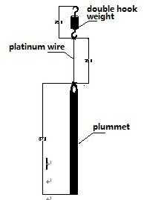

Figure 2: liquid kit assembly (unit: mm)

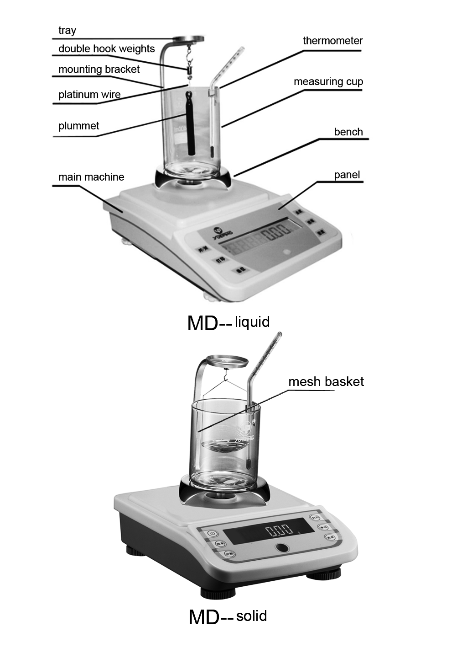

Figure 1: scale structure diagram

3. Put measuring cup on the center of bench, and fix thermometer to the inner wall of measuring cup. Pour liquid to be tested into the cup (until plummet is completely immersed.)
4. When reading is stable, push “MODE” button.The reading now is the density value of the liquid in the cup.(Attention: no air bubble should be produced on plummet, otherwise it will affect the result.)
5. If repeated measurements are needed, or the result is suspicious, push “TARE” button to have the scale at weighing status. Take measuring cup and liquid kit down and wipe plummet dry. Repeat measurement as per Steps from 1 to 3 under Four.

Five:Tare
Push “TARE” button shortly and “-------”displayed. When stable it displays “0”. The tare on the tray is removed.

Six: Solid density measurement
★ Push “Mode” button till it displays “den-S-”entering solid measurement mode.
1. Standard liquid density value setup:
Choose “den-s-“, let go of “MODE” button, now it displays standard liquid density value for test with last digit blinking. Push “TARE” button and blinking move toward to the left one position. Push “PRT” button to increase or push “UNT” button to decrease value. After value modified, push “CAL” button to save modified density value to enter solid density testing status. Or push “MODE” button to enter solid density measurement without saving value. If standard liquid density value setup not needed, just push “MODE” button to directly enter solid density measurement.
2. Hook mesh basket on, pour standard liquid about 275ML, and push “TARE” button till it displays “0.00g”.
3. Put solid to be tested on scale as Figure 1 shows. When the reading is stable, push “MODE” button. It will display “-----”. When it displays solid weight again, data is memorized successfully.
4. Take the solid down by tools like tweezers and put it in mesh basket gently. Let the
solid completely immersed into standard liquid. When the reading is stable, push “MODE” button again. The reading displayed now is the density of the solid.
5. If repeated measurements are needed, or the result is suspicious, push “TARE” button to have the scale at weighing status. Take measuring cup and liquid kit down and wipe plummet dry. Repeat measurement as per steps from 1 to 4 under Six.

Seven:Measurement modes
Choose measurement modes: push and hold “MODE” button, it displays in order “den-s-→den-L-→cou→100 %→-end- ”.
den-s-: solid density measurement mode, “-S -”also displayed on the upper right corner in the mean time
den-L-: liquid density measurement mode, “-L -”also displayed on the upper right corner in the mean time
cou: counting mode
100%: percentage measurement mode
-end-: quit mode setup and return to weighing mode.
When mode required is displayed, let go of “MODE” button to enter the
mode chosen. Density will be displayed without any unit symbol.

Eight:Backlight
When scale starts it enters backlight-on status. To adjust brightness, push and hold “TARE” button in the mean time push “UNT” button shortly, brightness can be adjusted in a loop. When appropriate brightness is found, let go of both “TARE” and “UNIT” buttons.

Nine:Mode
Scale mode can be switched as required. Push and hold “COU” button, “COU”, “100%”, “-END-”will be displayed in a loop.
“COU” is counting mode, “100%” is percentage mode and “-END-”is to quit counting or percentage mode to return to weighing status.

Ten:other features
1.Unit conversion:
Push “UNT” button shortly to choose the units available in “scale parameters setup”.
Make sure the unit to choose has been activated. For details refer to “unit setup”
options under “scale parameters setup”.

Liquid (distilled water) density temperature comparison table
temperature | ±0.0 | ±0.5
10～14 | 1.001 | 1.001
15～19 | 1.000 | 1.000
20 | 1.000 | 0.999
21～24 | 0.999 | 0.999
25～27 | 0.998 | 0.998

Don’t pull up the tray by force to avoid damages to sensor.

Fourteen:components

Electronic scale 1unit
Manual 1pc
Approval card 1pc
Mounting bracket 1pc
Thermometer 1pc
Thermometer clip 1pc
Weighing bench 1pc
Measuring cup 2pcs
Liquid kit: double hook weight, Platinum wire, plummet, measuring cup (small) 1 set
Solid kit: mesh basket, measuring cup (bigger) one kit
Power adapter (or power cord) 1pc
Standard weight (100g or 200g) 1pc

Attention: some content of the manual may change without prior notice due to product updates. If it is different with product in kind, product in kind prevails.

2. Counting function:
1）.Push and hold “COU” button until “COU” is displayed. It blinks with numbers. Push “COU” to choose the setup number among 10.20.50.100.200.500 and put on tray corresponding number of objects to be counted. Push “CAL” to confirm and “------”displayed. When stable, counting setup complete. When counting object unit weight is less than 2d, it displays “Err-3” indicating counting setup can not be carried out. Should take several objects as one piece to re-set up. Push “TARE” to return weighing status.
2）.During counting setup, push “TARE” to quit and return to weighing
status.
3）. After counting setup is done, push “COU” button to switch between counting and weighing status.
3.Percentage function:
1）.Push and hold “COU” button until “100%” is displayed. Let go of “COU” button then it blinks with 100. Put the object to be set as 100% on and push “CAL” button to confirm. “------” displayed and when stable it displays “100%”. Take away the object and put other object on, the percentage of the current object to the previous object will be displayed. If the setup object is less than 20d , it displays “Err-4”indicating the setup object is too small. Object weight needs to be added. Push “TARE” to return to weighing status.
2）.During percentage setup, push “TARE” button to return to weighing status.
3）.After setup is complete, push “COU” button to switch between percentage and weighing status.
4.Print function:
1）. One time print: set up as manual print mode in “scale parameters setup”.
Push “PRT” button every time data is output by scale one time.
2）. Continuous print: set up as continuous output in “scale parameters setup”.
Scale can output data continuously.
3）.Timing output: set up as timing output in “scale parameters setup”. Data
can be output at the set time.
4）.For details refer to print mode setup under “parameters setup”
5.Baud rate:
Four different baud rates to choose: 1200.2400.4800.9600. For details refer to
“baud rate setup” under “parameters setup”.
6.RS232 communication:
Scale uses RS232 UART communication. Data format 10digits. One digit as starting
location, 8 digits as data locations and one as stop location. No verification.

Data frame format:
1 2 3 4 5 6 7 8 9 10 11 12 13 14 15 16
K */Space + data data data data decim data data data unit unit unit OD OA
- al point

1.K:Data initial flag.
2.*/space: * indicates data unstable, space indicates data stable.
3.+/-：+ indicates data positive, - indicates data negative.
4.4-11：Weighing data output by scale. Decimal point position varies by different scale models.
5.12-14：Units of output data. For example: unit g output as: space+space+g.
6.15-16：Data end mark.

Eleven:parameters setup
Push and hold “COU” button to start scale. Let go of the button when “UNIT” displayed. Push again “COU” button shortly, below are displayed in a loop:
UNIT---buzz---A.0FF---b.9600---P.O---zero 1---bz 3---╊┏A02

1.Unit setup
Push “COU” button and choose “UNT” option. Push “UNT” button to choose units among g-kg-ct-lb-oz-ozt. Push “CAL” button to deactivate or activate the unit chosen.

2.Buzzer setup
Push “COU” button and choose “buzz1” option. Push “UNT” button to activate or deactivate. 1: indicates activated; 0 indicates deactivated.

3.Timing power off setup
Push “COU” button, choose A.0FF and then push “UNT” button to choose:
OFF: No automatic power off
30：Power off automatically after no button pushing or no weighing 30seconds
2： Power off automatically after no button pushing or no weighing 2minutes
5： Power off automatically after no button pushing or no weighing 5minutes
10：Power off automatically after no button pushing or no weighing 10minutes

4.Baud rate setup
Push “COU” button and choose “b.9600”option. Push “UNT” button to choose baud rate needed between “9600-1200-2400-4800”

5.Print mode setup
Push “COU” button and choose “P.0”option. Push “UNT” button to choose between “0-1-2-3-4”
0：Manual print
1：Print one time every 30seconds
2：Print one time every 60seconds
3：Print one time every 120seconds
4：continuous output
6.Zero point display range setup
Push “COU” button and choose “zero 1”option. Push “UNT” button to choose between 0-4d.

7.Return-to-zero setup
Push “COU” button and choose “bz 4” option. Push “UNT” button to choose between 0-5d. 0:1/3d; 1: 2/3d; 2:1d; 3:4/3d; 4:5/3d; 5:2d.

8.Zero point tracking setup
Push “COU” button and choose “ᅡ┏A0 2”option. Push “UNT” button to choose between 0-5.

After parameter setup is done or during setup, push and hold “COU” button until “stored” displayed. Set parameters saved and return to weighing status. If push “TARE” button then parameters will not be saved before returning to weighing status.

Twelve:error messages
Err_1: | Scale weighing module broken. Return to factory for repair.
Err_2: | Scale weighing data lost. Re-do the multi-point calibration.
Err_3: | Counting setup error. Weight of object for counting setup is too light. Should take several objects as one piece to re-set up
Err_4: | Percentage setup error. Weight of object for setup needs to be increased.
Err_5: | Calculated percentage value exceeds display range. Increase the weight of object for percentage setup or decrease the weight of object for calculation.

Blink with upper horizontal line: indicates accumulated weighing objects exceed measurement range. Should take off weighing objects immediately or re-do multi-point calibration.
Blink with bottom horizontal line: indicates scale way too light. Re-do multi-point
calibration. Or sensor is broken.

Thirteen: application notice
1.Plug in and warm up as per instructions before use.
2.Tare weight and weights add up can not exceed weighing range.
3.If weighing is not accurate, should do calibration by using standard weights.
4.If the tray needs to be taken off from scale, take off after turning the tray clockwise.

