一 Instrument appearance introduction.

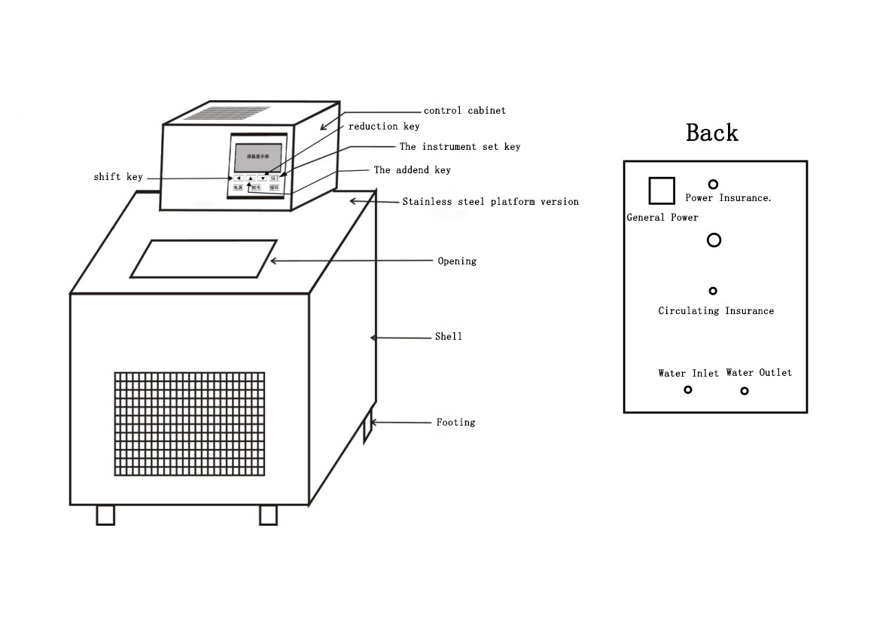

二 Features:

1 refrigeration system: With low noise totally enclosed compressor, air cooled with cooling speed, temperature stability is strong, etc.

2 control system: Latest proprietary software research and development of homemade temperature control technology, with high standards of Pt100 and all imports of electronic parts, etc.

3 circulating system: Consists of inner and outer loop irfpa outer loop slot can be constant temperature liquid, can establish the temperature field, also can be used as cold source to guide groove is cooling liquid into closed experimental container cooling, inner loop can make the liquid in the tank temperature was uniform and stable.

4 protection system: Refrigeration is overheated, over-current protection, call control system has overtemperature alarm, can be set overtemperature alarm temperature, the temperature of the upper and lower limits can cut off the load automatically when overtemperature, and other functions.

5 High-end LCD control instrument, simple operation, temperature stability is strong, P.I.D can automatically search or artificial adjustment

6 Accurate temperature correction function can reach 0.01 ℃, temperature fluctuation degree of up to + / - 0.02 ℃ ~ + / - 0.05 ℃ (depending on the type).

三 Technique Parameter:

|  |  |  |  |  |  |  |  |
| --- | --- | --- | --- | --- | --- | --- | --- |
| Model | Temperature range（℃） | Temperature fluctuation（±℃） | Working tank volume（mm3） | Slot opening （mm） | Groove depth(mm) | Circulating pump flow （L/min） | Power  （KW） |
| DC-0506 | -5-100 | 0.05 | 290x180x150 | 180x160 | 150 | 6 | 0.8 |

四： Operating Steps:

1、Slot in liquid medium, medium level cannot under working table 20 mm.

2、The selection of liquid medium:

A：When working temperature is below 8 ℃, liquid medium generally choose industrial alcohol.

B：Working temperature 8 ℃, 80 ℃, the pure water is generally selected liquid medium.

C：Working temperature 80 ℃ to 90 ℃, water and oil mixture is generally selected liquid medium.

D：Working temperature at 90 ℃ to 100 ℃, generally choose the oil liquid medium.

3、Circulating pump connection:

A：Circulating pump in the connection, connect the outlet and inlet hose.

B：external circulation pump for external loop connection, connect the outlet hose outside the tank container imports and exports to connect water inlet on the outside of the tank container.

4、plugged in, open the total power switch, then open "power" button and "cycle" button. (note: "total power switch on the back of the instrument).

5、instrument operation is as follows:

A：Instrument button shows:

**shift key** ▲The addend key ▼The reduction key**SET setting function key**

B：temperature setting:

Such as working temperature is higher than the environment temperature, according to the set function keys into the temperature set point. Value bottom flashing, press the shift key before at this time the addend, set up your required working temperature, press set again the function keys and save the setting, the measurement is shown in the groove of the temperature of the liquid medium, then into a state of microcomputer automatic control.

C：Such as working temperature below the environment temperature, open "cooling" button (note: the above the liquid temperature 40 ℃) could not be opened, according to the set function keys into the temperature set point. Value bottom, at this time to press the shift key and press reduction, set up your required working temperature, press set again the function keys and save the setting, the measurement is shown in the groove of the temperature of the liquid medium, then into a state of microcomputer automatic control.

6、temperature and actual temperature measurement, correction:

By setting function button for more than 5 seconds, the window shows the word "PASS", press the add key input password "0001" at this time, again by setting the function keys into the actual revision status, the window shows the word "SC" at this point, press the add key such as high temperature, low press reduction, fix complete set according to the function keys for 5 seconds or so quit again can. Time measured value reaches the working temperature stability experiment or test can be carried out when a period of time.

五：Application notice：

1、Before using slot should be in liquid medium. (note: liquid not contain acid alkali).

2、The total power of the power is to be greater than or equal to the instrument, the power must have a good "grounding" device. Using the voltage will be subject to technical parameter table.

3、Device should be placed in ventilated dry place, back and sides leave obstacles 300 mm distance。

4、After use, all switch off and unplug the power plug.

**[packing](C:/Users/Administrator/AppData/Local/Yodao/DeskDict/frame/20150402093101/javascript:void(0);) [list](C:/Users/Administrator/AppData/Local/Yodao/DeskDict/frame/20150402093101/javascript:void(0);)**

1 main energy 1set

2 cover plate 1piece

3 specification 1piece

4 certification 1piece

5 warranty 1piece